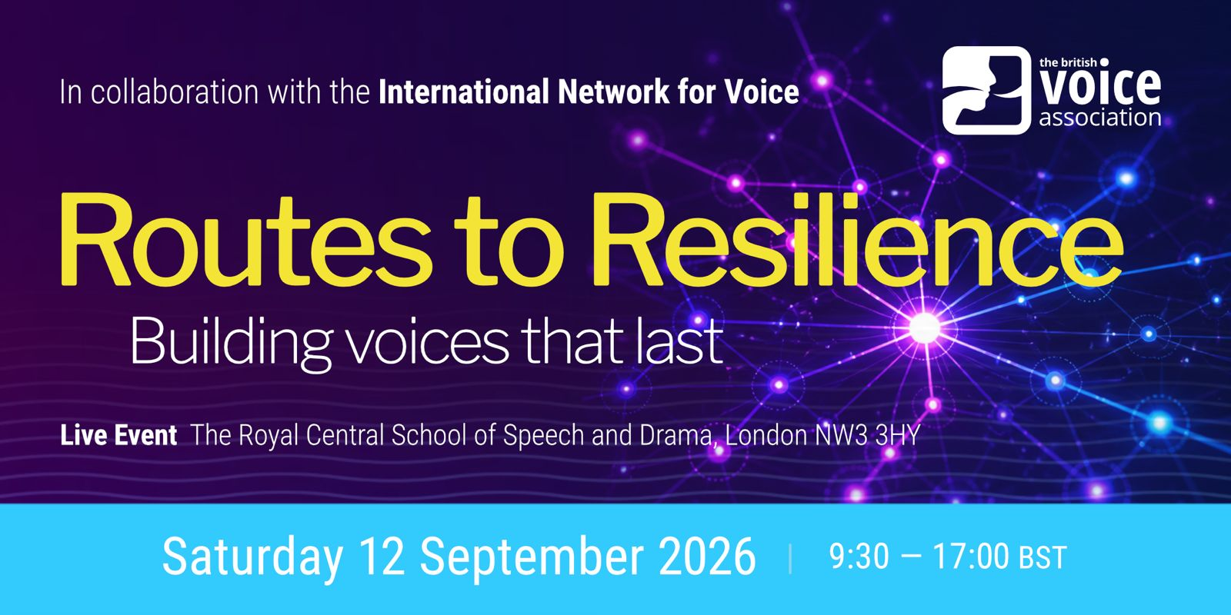

PRESIDENT’S STUDY DAY, 9.30 -17.00 (live in-person event)
ROUTES TO RESILIENCE: Building Voices that Last

This multi-disciplinary (in collaboration with the International Network for Voice) day delves into vocal resilience: helping a voice rebuild and recover after injury and keeping it working under pressure. We invite you (voice specialists, performers, non-professional voice users, teachers, and speech therapists) to step outside your usual mind and tool set. Sharpen your skills with practical strategies and insights from our specialists in holistic voice rehabilitation, movement therapy, nutrition and strength training.

With
LORI SONNENBERG (Keynote Speaker) - Speech and Voice Pathologist, Singing Voice Specialist, Chicago, USA
REBECCA MOSELEY-MORGAN – Singer, Researcher, Singing Teacher
JANE OAKSHOTT – BVA President, Voice and Drama Coach
DUNCAN ROCK - Physiotherapist and Nutrition Specialist
MORWENNA ROWE – Royal Central School of Speech & Drama, and RADA
SONG YI WANG – Movement and Tai Chi Specialist
JENEVORA WILLIAMS – Singing Voice Rehabilitation Specialist

NB: This is a live event. No video recording will be available.

The British Voice Association (BVA) brings together scientific knowledge and artistry. We connect, educate, and support voice professionals, cross-disciplinary teams and the public, to access and share the latest research and best practice in vocal care, rehabilitation, optimal function and communication.

The International Network for Voice (INV) is a gratis membership organisation that facilitates continuing professional development for and with voice pedagogues, practitioners and researchers around the globe.
LIVE EVENT
ROUTES TO RESILIENCE: Building Voices that Last
Saturday 12 September 2026, 9.30-17.00
The Royal Central School of Speech and Drama, London NW3 3HY (Swiss Cottage Tube)

PROGRAMME

9:30 Doors open for Registration
10:00 Welcome and Introduction (BVA President, Jane Oakshott MBE)

KEYNOTE: Lori Sonnenberg
A Holistic Model for Sustainable Voice

11:00 Coffee/Tea

11.30 Morwenna Rowe
Resilient Voice from the Feet Up

12:30 Lunch (President Handover)

13:15 Song Yi Wang
Tai Chi Warm-Up with integrated breathwork

13:30 Duncan Rock
Muscle as a Health Currency: Building Resilience for Vocal Performance

14:15 Rebecca Moseley-Morgan
Sing Stronger for Longer

15.15 Coffee/Tea

15.45 Jenevora Williams (Chair)
Routes to Resilience: Crossroads and meeting points
Summary overview, questions, and open discussion

16:45 Building Closes

PRICING:
BVA members: £125/£105 (early bird rate before 12 August)
Non-BVA members: £135/£125 (early bird rate before 12 August)
Student/Recent graduate/Senior: £40

Refreshments are part of the fee. Lunch is not supplied. We recommend you bring your own.

For further details: administrator@britishvoiceassociation.org.uk or www.britishvoiceassociation.org.uk

TO BOOK: https://www.eventbrite.co.uk/manage/events/1993148970224/promote/eventbrite-ads/new/settings?eid=1993148970224&isImmediatelyPostPublish=true



ROUTES TO RESILIENCE: Building Voices that Last - 12 September 2026
TITLES AND PRESENTER BIOGS – In order of presentation

KEYNOTE
Route to Resilience: A Holistic Model for Sustainable Voice
LORI SONNENBERG
Speech and Voice Pathologist, Singing Voice Specialist, Chicago, USA
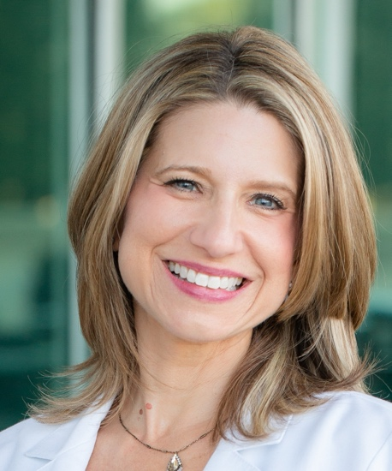
What does it truly mean to have a resilient voice? Resilient voices are not the ones that never struggle—they are the ones whose owners know how to adapt. Vocal resilience is not simply the absence of injury or fatigue; it is the ability to recognize changing vocal demands, respond thoughtfully to challenges, recover effectively, and make informed decisions that support long-term vocal health. Drawing on clinical experience with singers and other professional voice users, this keynote combines voice science with practical clinical strategies for cultivating vocal sustainability. Participants will explore evidence-informed approaches to self-monitoring, vocal load management, efficient voice use, recovery, and the psychological dimensions of vocal health. Rather than viewing resilience as the absence of challenge, attendees will be encouraged to embrace it as the capacity to adapt, recover, and thrive with confidence throughout every stage of their professional journey.

Lori Sonnenberg is a highly specialized Voice SLP and Singing Voice Specialist with over 27 years of experience in singing voice rehabilitation, speech-language pathology, and upper airway disorders. Having worked exclusively with professional and aspiring voice users throughout her career, she has developed a unique subspecialty in helping singers navigate muscle tension dysphonia (MTD)-type diagnoses, vocal pathologies, post-operative rehabilitation, vocal fatigue, and complex singing voice concerns.

Lori began her career in a busy laryngology practice before founding Sonnenberg Voice, a leading specialty practice providing comprehensive voice care in the Chicago area and beyond. Under her leadership, Sonnenberg Voice has grown into a trusted resource for specialized clinical care, high-quality voice education, professional mentoring, and interdisciplinary collaboration.
Through workshops, conference presentations, online educational content, and the Voice Teacher Collective, Lori and her team equip singers, voice teachers, and clinicians with practical, evidence-informed strategies that bridge voice science and real-world application.

Lori holds ASHA's Certificate of Clinical Competency (CCC-SLP), is an active member of the National Association of Teachers of Singing (NATS), and a frequent national and international speaker on topics related to singing voice rehabilitation, vocal health, and collaborative voice care.

The Foot, the Floor, and the Voice
MORWENNA ROWE
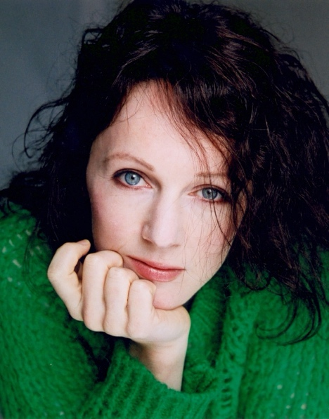
Small changes in the foot can produce remarkable shifts throughout the whole body. Taking the surprisingly influential big toe as a starting point, this practical workshop explores how sensory awareness at the floor organises the body in relation to gravity, and how that organisation frees the breath, supports resonance and builds vocal endurance. We will mainly work standing, experimenting with contact, weight transfer and foot activation, arriving at a state of physiological readiness from which speech can emerge with greater ease and responsiveness. Suitable for anyone who stands up and speaks.

Morwenna Rowe is Programme Leader for MA Acting at the Royal Central School of Speech and Drama, a voice practitioner and actor trainer with two decades' experience across UK conservatoires, screen and stage coaching, and international consultancy. She read English at Cambridge, studied performance with Grotowski collaborators Vlado Šav and Abani Biswas, trained as an actor with Philippe Gaulier, Bob McAndrew and Larry Moss, and trained in voice under David Carey at Central. She has taught at RADA, Rose Bruford, BADA and for Rutgers at the Globe, and coached in the West End, on screen and in regional theatre, including Trevor Nunn's Wars of the Roses. For twenty years she has developed an integrated, physiology-centred approach that uses voice as a lens through which to train acting, rather than as an end in itself.

Tai Chi Fundamentals: Breathwork practice
SONG YI WANG

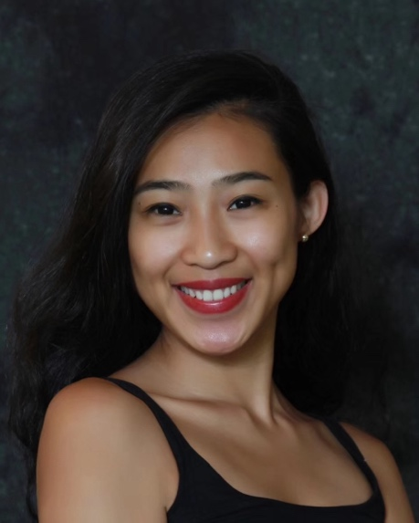
A gentle and mindful Tai Chi experience combining Dan Tian breathing, flowing movements, and body awareness. Through this practice, participants will be guided to relax the body and mind, improve balance and physical awareness, release tension, and enter activities with a calmer and more focused state of being.

Song Yi Wang is a Tai Chi practitioner and movement artist with an MFA from Royal Central. Her practice combines traditional Tai Chi principles with breathwork and mindful movement, exploring the relationship between body awareness, creativity, and wellbeing. Through teaching and workshops, she shares Tai Chi as a way to cultivate balance, presence, and inner connection.

Muscle as a Health Currency: Building Resilience for Vocal Performance
DUNCAN ROCK
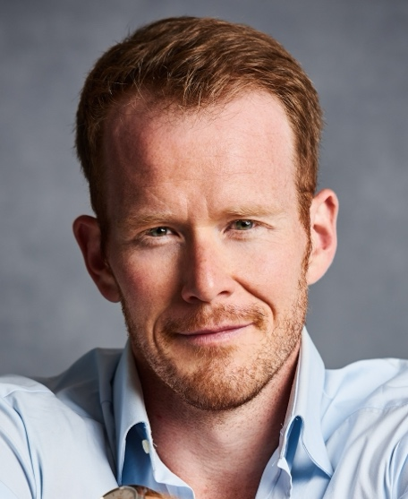
Peak vocal performance depends on far more than the voice alone. In this talk, we'll explore why skeletal muscle is one of the strongest predictors of long-term health, resilience, and performance. We'll discuss how increasing and maintaining lean muscle mass improves body composition, reduces the risk of chronic disease and all-cause mortality, and enhances physical capacity throughout life. Most importantly, we'll connect these principles to the unique demands of singers. We'll explore how strength, movement quality, and overall physical robustness support breath control, posture, recovery, injury resilience, and consistent vocal performance. Whether you're a professional performer or simply interested in optimising your health, this session will provide practical, evidence-based insights into using muscle as the foundation for a healthier, more resilient body—and a more resilient voice.

Duncan Rock is an operatic baritone who has spent over 15 years performing at many of the world's leading opera houses, including the Royal Opera House, Covent Garden, the Metropolitan Opera, Teatro Real, Glyndebourne, and English National Opera.
Alongside his performing career, Duncan is an HCPC-registered physiotherapist with master's degrees in Physiotherapy and Human Nutrition. He is the founder of Life is Movement Clinic, a specialist physiotherapy and rehabilitation clinic, and co-founder of the Sussex Longevity Clinic, a medical practice dedicated to improving healthspan and lifespan through evidence-based medicine.
Drawing on his unique experience as both an international performer and clinician, Duncan combines the worlds of performance and medical science to help singers better understand their bodies and apply the latest evidence in health, rehabilitation, and exercise science to optimise vocal performance, resilience, and long-term wellbeing.

Sing Stronger for Longer
REBECCA MOSELEY-MORGAN
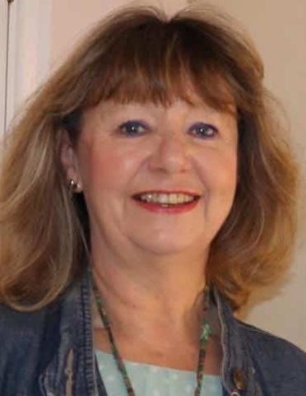
This interactive session is a demonstration and explanation of essential technique for the older singer to help them maintain vocal functionality despite any age-related changes. Delegates will be invited to join in and try the exercises for themselves.
Royal College of Music alumna, Dr Rebecca Moseley-Morgan, has worked nationally and internationally as a professional opera singer. She is now a leading exponent of working with mature voices using innovative, science-informed pedagogy based on her doctoral research at University College, London. She gives singers the technical skills they need to deliver the requirements of the music and to maintain optimal vocal functionality despite age-related changes. She works with all levels of individual singers and with choirs through one-to-one training, workshops and seminars. Rebecca’s work has been presented at major conferences throughout Europe and the UK. She is currently writing a book and devising a new vocal pedagogy training course for teachers of mature voices. Rebecca was previously BVA Chair of Education, is currently the Treasurer, and is BVA President-Elect (2026-2028).

Routes to Resilience: Cross Road and Meeting points
JENEVORA WILLIAMS
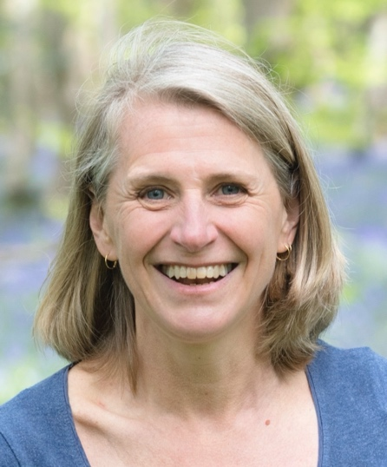

Jenevora Williams, PhD, is an expert in the fields of vocal health and singing teaching. After a successful career in opera, Jenevora turned her attention to investigating healthy and efficient vocal function, combining academic study and practical experience to understand the human voice. She was the first singing teacher in the UK to be awarded a PhD in voice science, won the BVA Van Lawrence Prize in 2010 for her outstanding contribution to voice research. Her book Teaching Singing to Children and Young Adults has been enormously popular with singing teachers throughout the world. A substantially updated third edition was published in 2024. Jenevora is director of Vocal Health Education and Evolving Voice, providing imaginative and rigorous training courses for singing teachers, voice professionals, and the first generation of Voice Rehabilitation Specialists worldwide. As a teacher of singing, she works with professional singers of all ages in both voice rehabilitation and career mentoring. https://jenevorawilliams.com

